**Final Project Report**

Group 1

College of Professional Studies, Northeastern University

ALY 6060- Decision Support & Business Intelligence

Professor Mykhaylo Trubskyy

June 30th, 2024

**Group Members:**

Mariana Aguilera

Manav Jatakia

Harsh Bharatbhai Anadkat

**Introduction**

In this analysis, we will first discuss the evolution of law enforcement and data analytics, from paper-based systems to AI-driven technologies. Then, we will explore the integration of various data analytical techniques in policing, followed by an examination of AI's impact on predictive analytics, surveillance, and investigations. Finally, we will address critical ethical considerations arising from AI adoption in law enforcement, including privacy, bias, and implications for officer decision-making. These topics show the main changes and challenges in modern policing driven by data and technology.

**Analysis**

*Evolution of Law Enforcement and Data Analytics*

Before the 1950s, police data was primarily stored in paper-based filing systems. This manual approach was labor-intensive and limited the ability to efficiently analyze and share information. This changed in the 1960s when a very important development transformed data management in law enforcement. By 1967, the FBI established the National Crime Information Center (NCIC). The NCIC provided a centralized database that allowed agencies across the country to share information quickly and securely. This change greatly enhanced the ability to track and apprehend criminals. Soon after, the world also followed these steps.

The 1990s saw the widespread adoption of computer programs for crime analysis. These programs allowed for more sophisticated data analysis, helping police to identify crime patterns, predict criminal activity, and allocate resources more effectively. In the 2000s, police forces introduced control rooms equipped with advanced tools that integrated call data, maps, and resource deployment.

The 2020s brought the use of artificial intelligence (AI) for facial recognition, surveillance, and anomaly detection. Real-time crime centers began to integrate Computer-Aided Dispatch (CAD), gunfire detection systems, and live video feeds, providing law enforcement with unprecedented levels of information and situational awareness. These technologies not only improved the ability to prevent and respond to crimes but also prioritized officer safety and efficiency.

Post-2020s, there have been significant advancements and increased spending in real-time surveillance, predictive analytics, mobile applications, body cameras, and AI-driven data analytics. These innovations show the importance of data in law enforcement. For example, predictive analytics can forecast crime hotspots, allowing for strategic deployment of resources. Mobile applications and body cameras enhance transparency and accountability, while AI-driven data analytics provide deeper insights into crime trends and operational efficiency.

A study conducted across several public safety agencies in the U.S. reveals plans to implement various technological capabilities to enhance the analysis of police data, as detailed below:

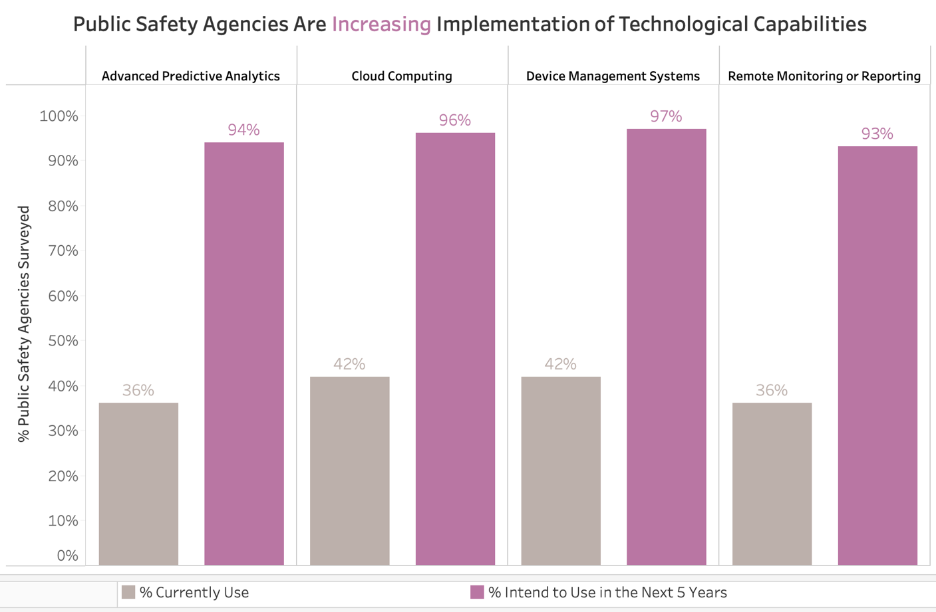

*Source: lowrysolutions.com*

While some agencies are not currently utilizing the available technologies as of 2020, the survey indicates that nearly all of them plan to integrate data technologies, such as advanced predictive analytics, cloud computing, and remote monitoring, into their policing operations by 2025 (Ashenbrenner).

*Data Analytical Techniques used in Law Enforcement*

Law enforcement agencies use a variety of data technologies to enhance their operations. Statistical analysis methods are used to identify patterns and trends in crime data, helping to understand and predict criminal behavior. Predictive analytics goes a step further by forecasting future criminal activities based on historical data and current trends, allowing agencies to proactively address potential issues. Geospatial analysis involves mapping crime patterns and hotspots, which assists in the strategic allocation of resources and informed decision-making. Additionally, text analysis is used to extract valuable information from unstructured data sources such as police reports, witness statements, and social media, providing potential leads and deeper insights into criminal activities.

These technologies enable law enforcement to operate more efficiently. An example of how data can be used by police to identify crime trends and areas for improvement is illustrated below. The first graph displays the murder clearance rates of different police agencies in Massachusetts. The clearance rate is calculated by dividing the number of crimes cleared, regardless of the year they occurred, by the number of new crimes in the calendar year, which makes it standardized for us to be able to compare cities with different population sizes. This graph clearly highlights departments that need improvement, such as those in Boston and Springfield, which had average murder clearance rates of less than 30% in 2020.

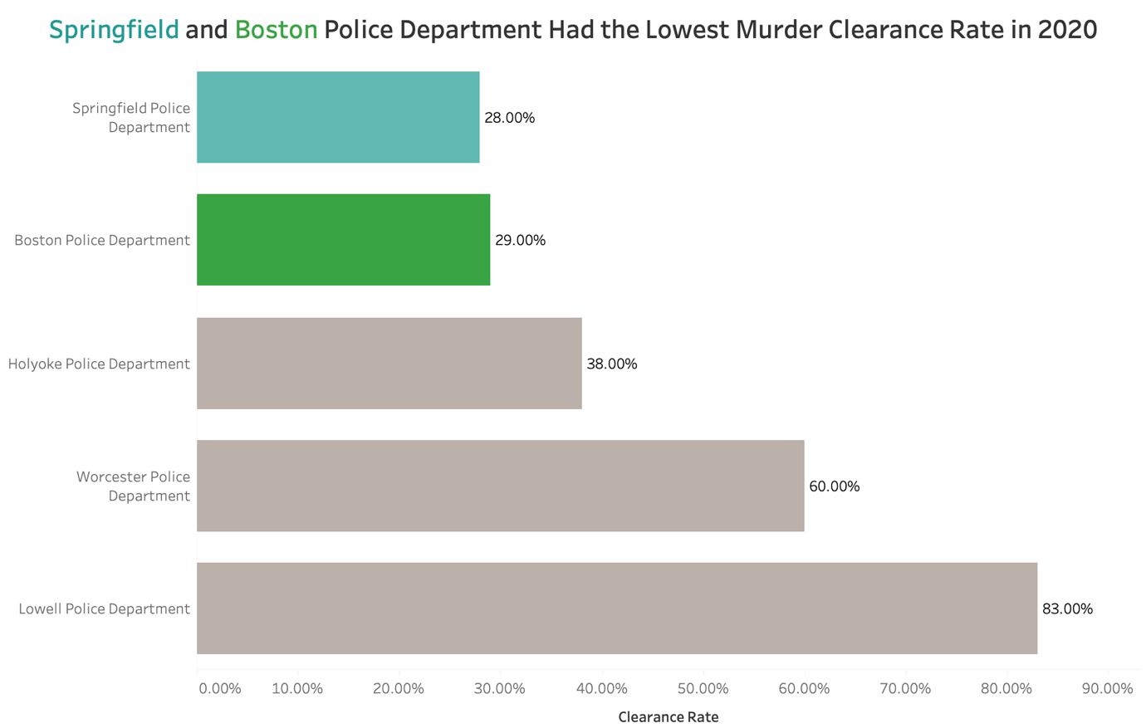

*Note: Clearance rate is calculated by dividing the number of crimes cleared, regardless of the year they occurred, by the number of new crimes in the calendar year.*

*Source: The Marshall Project*

The police data can also provide insights into the types of crimes being committed. The graph below indicates that in the U.S. in 2022, the most commonly reported crime was larceny/theft.

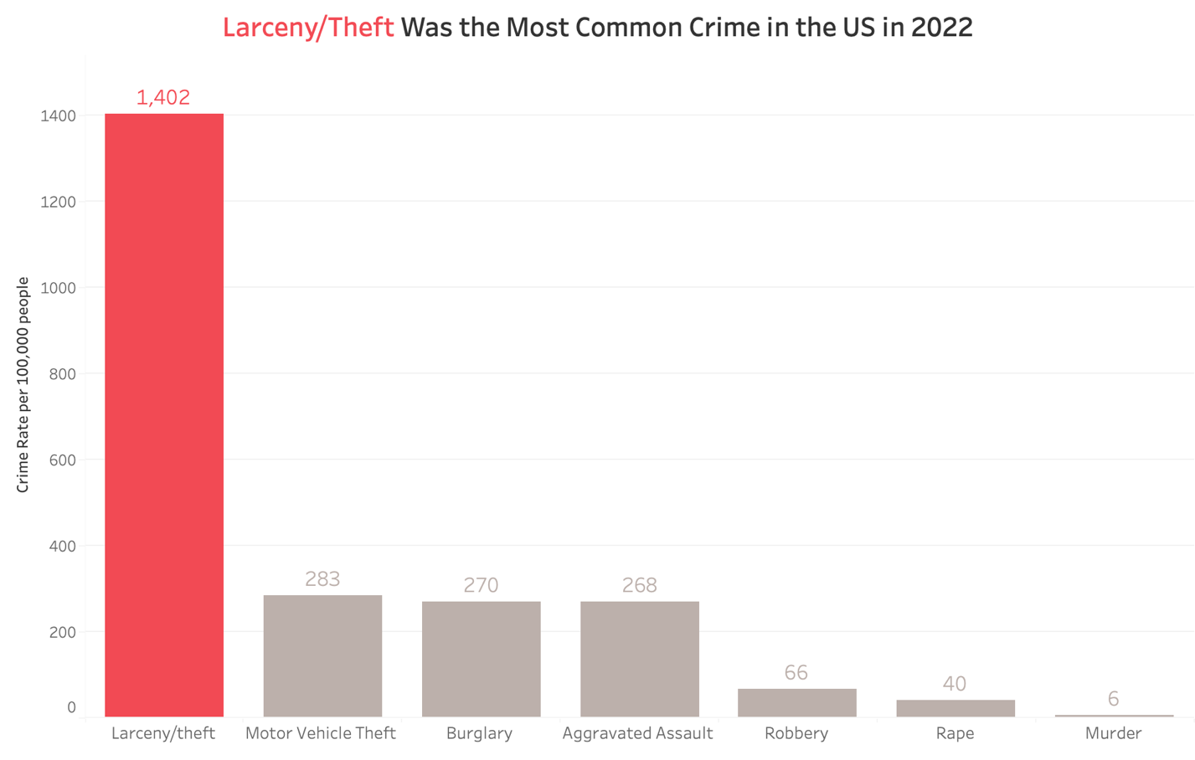

*Source: Pew Research Center*

With this information, police agencies can work to improve the theft levels in the US and introduce different programs and security measures as they see fit.

*Integration of AI in Law Enforcement*

With the rise of AI in the recent years, it has also been used in law enforcement around the world. AI has been integrated into law enforcement in several impactful ways. Predictive statistics uses AI to anticipate high-crime areas, allowing agencies to allocate resources proactively and prevent crimes before they occur. AI also enhances data analysis by uncovering trends and potential criminal activities within large datasets.

In the realm of surveillance and monitoring, AI assists with facial recognition and real-time surveillance, identifying suspicious behavior more efficiently. Additionally, AI plays a crucial role in investigations by aiding in crime scene analysis, suspect identification, and extracting insights from unstructured data such as reports and social media.

Investment in AI is accompanied by increased spending in the law enforcement sector. Specifically, AI adoption in this field is expected to grow at a compound annual growth rate (CAGR) of 29.9% from 2019 to 2025. This trend is illustrated in the visualization below, depicting a significant rise in AI investment anticipated in the coming years.

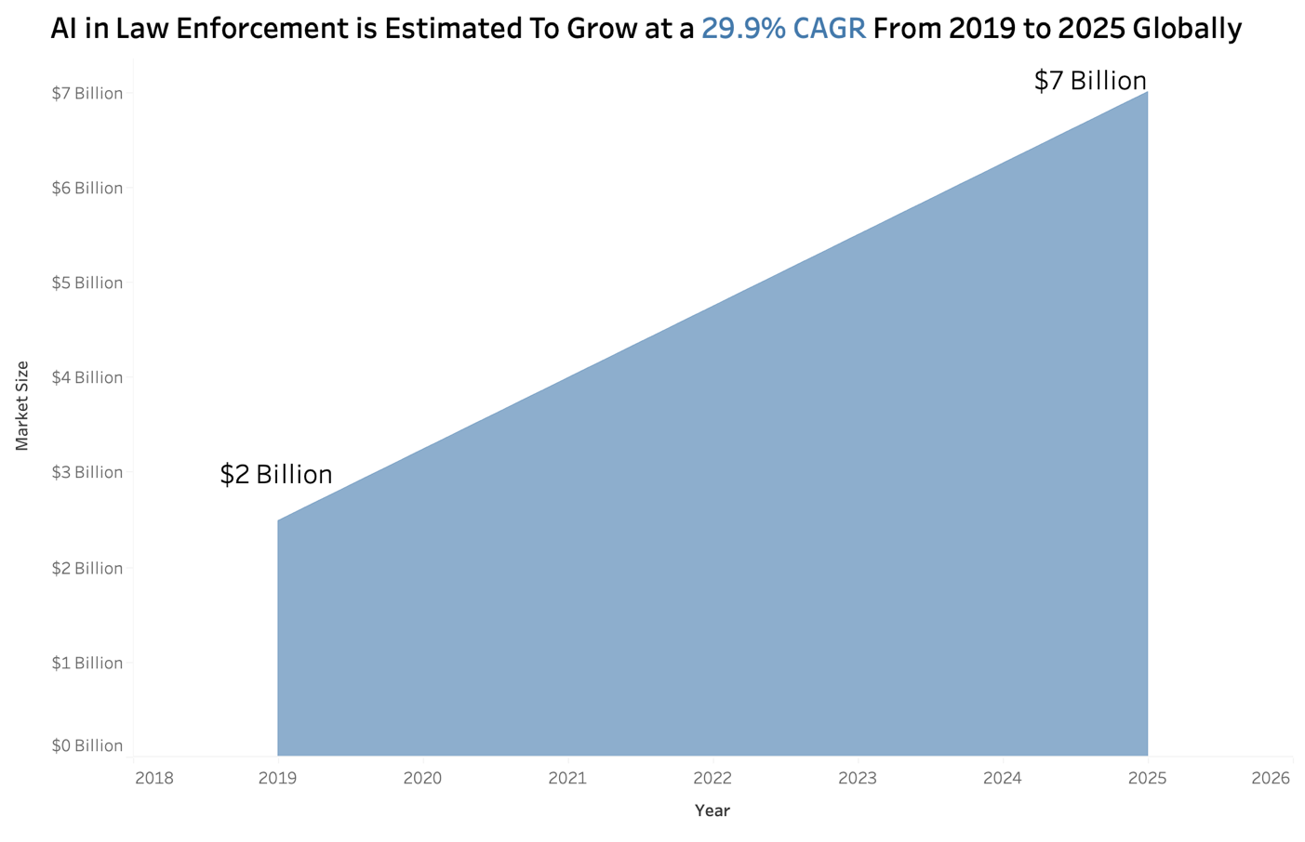

*Source: Worldmetrics Report 2024*

*Ethical Considerations in Applying AI in Law Enforcement*

Despite the advancements in technology used in law enforcement, particularly with the integration of AI, there remain critical ethical considerations that must be addressed. To start, privacy and data protection are critical concerns arising from the expanded deployment of surveillance technology and increased data collection for AI-driven crime prediction. There is a risk that these practices could infringe upon citizens' rights to privacy.

Bias is another significant issue, as AI systems trained on biased data may perpetuate discriminatory practices, particularly in areas like resource allocation and suspect identification. Research conducted by MIT Media Lab indicates that computer programs are more prone to inaccurately identifying darker-skinned females compared to other genders and races. A summary of the findings is depicted in the visualization below.

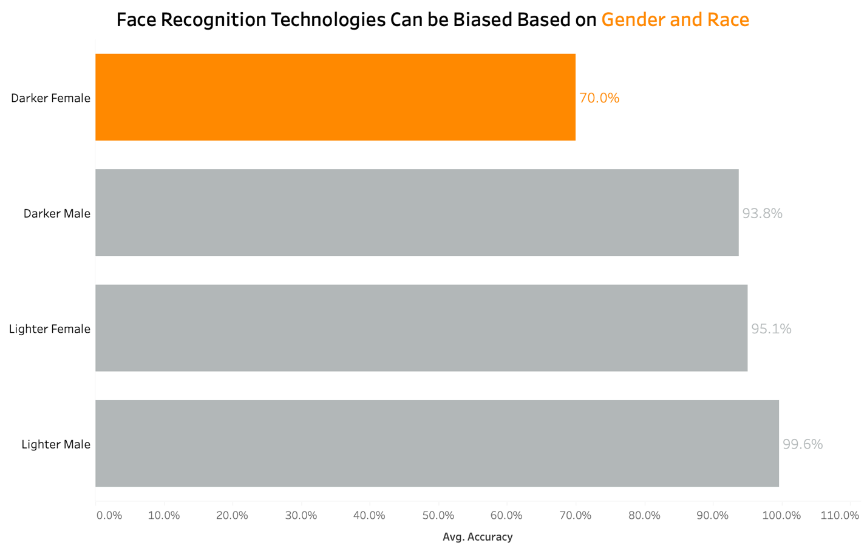

*Source: M.I.T Media lab*

*Note: Average Accuracy based on 3 technologies.*

The AI prediction is based on historical criminal data and police activity which has always targeted the Black community. This has led to inaccurately identifying darker-skinned females compared to other genders and races. This could put an innocent person behind bars while the culprit is roaming free. Therefore, excessive reliance on AI for decision-making could potentially limit an officer's discretion and ability to exercise judgment in urgent or complex situations.

**Conclusion**

The integration of data analytics and artificial intelligence (AI) within law enforcement agencies presents both promising opportunities and critical challenges. The growing use of technology such as predictive analytics, geospatial analysis, and AI-powered surveillance and monitoring has considerably improved the efficiency and effectiveness of crime prediction, resource allocation, and investigation operations. In fact, the investment in AI is expected to grow at a compound annual growth rate (CAGR) of 29.9% from 2019 to 2025. However, the path ahead is not without challenges. The significant investment in AI and its predicted growth highlights the necessity of resolving ethical concerns, notably those related to privacy and potential biases in AI systems.

**References**

Christopher Rigano, “Using Artificial Intelligence to Address Criminal Justice

Needs,” NIJ Journal 280, January 2019, https://www.nij.gov/journals/280/Pages/using-artificialintelligence-to-address-criminal-justice-needs.aspx.

Gramlich, J. (2024, May 13). What the data says about crime in the U.S. Pew Research Center. <https://www.pewresearch.org/short-reads/2024/04/24/what-the-data-says-about-crime-in-the-us/>

Jacobson, N. (2023, January 13). The Evolution and History of Law Enforcement Technology. CPI OpenFox. https://www.openfox.com/the-evolution-and-history-of-law-enforcement-technology/

Jumpfactor. (2024, February 29). Study: Public Safety Agencies Need to Speed Up Technology Adoption in Order to Overcome Some of the Greatest Operational Challenges of This Generation. Lowry Solutions. <https://lowrysolutions.com/blog/study-public-safety-agencies-need-to-speed-up-technology-adoption-in-order-to-overcome-some-of-the-greatest-operational-challenges-of-this-generation/>

Lindner, J. (2024, June 17). Ai In Law Enforcement Statistics • WorldMetrics. WorldMetrics. <https://worldmetrics.org/ai-in-law-enforcement-statistics/#sources>

Li, W., & Lartey, J. (2022, January 12). As Murders Spiked, Police Solved About Half in 2020. The Marshall Project. <https://www.themarshallproject.org/2022/01/12/as-murders-spiked-police-solved-about-half-in-2020>

McGregor, A. (2021, March 1). The evolution of data in policing. Capita. <https://www.capita.co.uk/our-thinking/evolution-of-data-policing>

Technologies, Z., & Technologies, Z. (2024, February 2). Unveiling the Power of Data Analysis in Law Enforcement - Zinatt Technologies, Inc. Zinatt Technologies, Inc. - Bringing Your Data Into Focus. <https://zinatt.com/unveiling-the-power-of-data-analysis-in-law-enforcement/>

Vomiero, J. (2018, February 11). Studies show facial recognition software almost works perfectly – if you’re a white male. Global News. <https://globalnews.ca/news/4019123/facial-recognition-software-work-white-male-report/>